What is fiware

Area in which fiware is working

~~Architecture~~

How does it work

Open source vs proprietary

Technology used

Difference by fiware and linux

Investment of EU in fiware and companies, how EU uses fiware, area of interest, development till date, companies using fiware

**Components:-**

The fiware project

Fiware ops

Fiware mudus

Fiware accelerator

Fiware lab

Fi-ppp

Fi-infinity

Xifi

Data Models: - <https://github.com/Fiware/dataModels>

Weather: - <https://github.com/Fiware/dataModels/tree/master/Weather>

<http://www.slideshare.net/fi-ware>

<http://www.oascities.org/>

<https://www.fiware.org/2013/10/02/fi-ware-smart-city-projects/>

<http://www.slideshare.net/FI-WARE/funding-opportunities-for-fiware>

The **FIWARE** Community is an independent open community whose members are committed to materialise the FIWARE mission, that is: “to build an open sustainable ecosystem around public, royalty-free and implementation-driven software platform standards that will ease the development of new Smart Applications in multiple sectors”.

The FIWARE Community is not only formed by contributors to the technology (the FIWARE platform) but also those who contribute in building the FIWARE ecosystem and making it sustainable over time. As such, individuals and organizations committing relevant resources in FIWARE Lab activities or activities of the FIWARE Accelerator, FIWARE mundus or FIWARE iHubs programmes are also considered members of the FIWARE community.

The FIWARE platform provides a rather **simple yet powerful set of APIs** (Application Programming Interfaces) that ease the development of Smart Applications in multiple vertical sectors. The specifications of these APIs are **public and royalty-free**. Besides, an **open source reference implementation of each of the FIWARE components is publicly available** so that multiple FIWARE providers can emerge faster in the market with a low-cost proposition.

FIWARE Lab is a non-commercial sandbox environment where innovation and experimentation based on FIWARE technologies take place. Entrepreneurs and individuals can **test the technology** as well as their applications on FIWARE Lab, exploiting **Open Data published by cities and other organizations**. FIWARE Lab is deployed over a geographically distributed network of federated nodes leveraging on a wide range of experimental infrastructures.

The FIWARE Acceleration Programme aims at promoting the **take up of FIWARE technologies**among solution integrators and application developers, **with special focus on SMEs and start-ups**. Linked to this program, the EU launched an ambitious campaign in September 2014 mobilizing 80M€ to support SMEs and entrepreneurs who will develop innovative applications based on FIWARE. Similar programmes may be defined in other regions.

Although it was born in Europe, **FIWARE has been designed with a global ambition**, so that benefits can spread to other regions. The FIWARE Mundus programme is designed to bring coverage to this effort **engaging local ICT players and domain stakeholders, and eventually liaising with local governments** in different parts of the world, including North America, Latin America, Africa and Asia.(Fiware Mundus)

**Think globally but act locally** is a distinguishing mark of the FIWARE ecosystem. The network of FIWARE iHubs will play a fundamental role in building the community of developers adopting and contributing to FIWARE, acting at local level. The FIWARE iHubs Programme aims at **supporting the creation and the operations of iHubs nodes worldwide.**

Independence in decision making, openess, transparency and meritocracy are the cornerstone and founding principles of the FIWARE Community. An important part of the "FIWARE Culture" is also the proper balance between the individuals who invest their time and effort, the companies that build businesses on FIWARE and the application developers who build and deploy new applications based on FIWARE technologies. The structure of the the FIWARE Community encourages all forms of contributions and provides safeguards against losing the balance between the various members of the community.

The work in the FIWARE Community is organised in dedicated teams: FIWARE Chapters, Technical Committees and Ecosystem Support Committees. FIWARE Chapters and Technical Committees deal with coordination of activities that are of technical nature, while FIWARE Ecosystem Support Committees are focused in non-technical relevant activities such as those linked to the FIWARE Accelerator, the FIWARE Mundus or the FIWARE iHubs programmes.

**WHAT IS FIWARE**

The **FIWARE** Community is an independent open community whose members are committed to materialise the FIWARE mission, that is: “to build an open sustainable ecosystem around public, royalty-free and implementation-driven software platform standards that will ease the development of new Smart Applications in multiple sectors”.

The FIWARE Community is not only formed by contributors to the technology (the FIWARE platform) but also those who contribute in building the FIWARE ecosystem and making it sustainable over time. As such, individuals and organizations committing relevant resources in FIWARE Lab activities or activities of the FIWARE Accelerator, FIWARE mundus or FIWARE iHubs programmes are also considered members of the FIWARE community.

FIWARE is a rich and versatile suite of standardised software components which can be used as the basis for creating advanced Internet services and apps faster and at lower cost. It is one of the results of the EU's Public-Private Partnership on the Future Internet. FIWARE was 'born in Europe' and is now being adopted globally. It is today a vibrant community of more than 5000 people from industry, SMEs and startups, from developers and user community in business and the public sector.

FIWARE provides enhanced OpenStack-based cloud hosting capabilities and a rich library of components. These components, called the “Generic Enablers”, provide open standard APIs (Application Programming Interfaces) that make it easier to connect to Internet of Things devices, process data and media in real-time at large scale, perform Big Data analysis or incorporate advanced features to interact with the user. In FIWARE, API specifications are public and royalty-free, supported by open source reference implementations. Thanks to that, alternative FIWARE providers can emerge faster in the market.

One key user segment is the public sector and notably cities trying to get the most out of the internet.  As part of the [Open and Agile Smart Cities](http://oascities.org/) initiative, almost 90 cities have expressed already their desire to use the FIWARE open service platform technology to accelerate smart city services. The open nature of FIWARE makes it a preferred candidate for innovation procurement by regions and cities.

First, if you haven’t heard about FI-WARE before, you'll need a bit of context. In 2011 the European Commission got together with major players from the Information & Communications Technology Industry (all these) to form a partnership in order to place Europe in a leading position for the “next stage” of Internet (AKA Future Internet) The**Future Internet Public-Private Partnership** or [**FI-PPP**](http://fi-ppp.eu/).

One of the main programs of this partnership is **FI-WARE**, a project that aims to create a **standard platform that facilitates the development of Future Internet applications** and an environment where developers, entrepreneurs and application sponsors can connect.

**Architecture and how does is work**

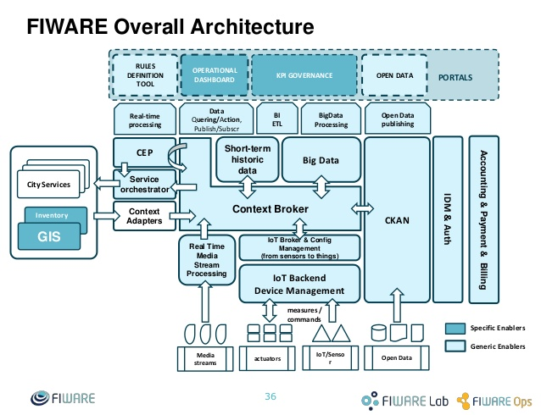

Architecture

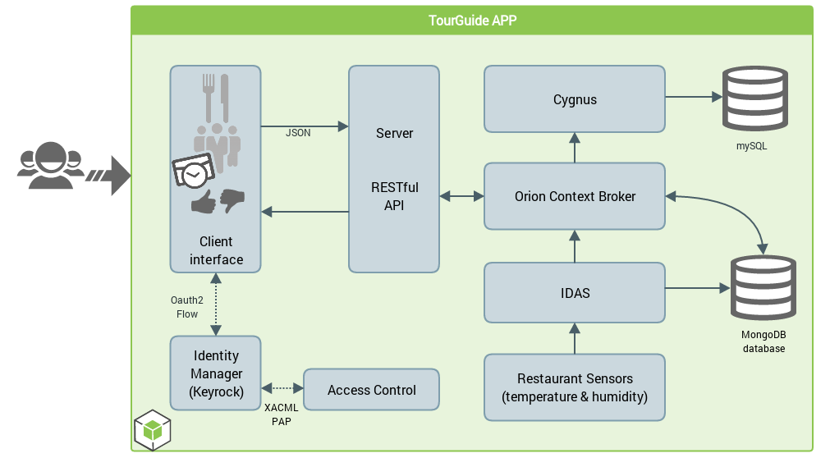

Architecture of Fiware

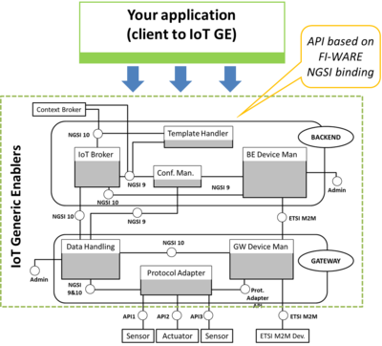

Client Accessing IoT GE

**Investment of EU in fiware**

The Fiware project is a public-private partnership between the EU and a consortium of companies that started in 2011. Fiware is royalty-free and open source, which means that it can be used free of charge, and developers may further develop it as well. Proprietary software, as opposed to open source, can only be used if you have acquired a license. Examples include Microsoft Windows, Adobe Photoshop, and Mac OS X.

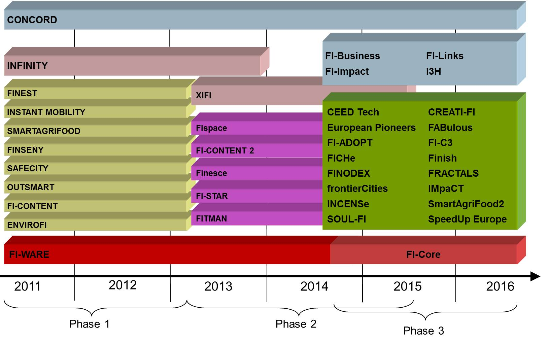

**Roadmap of FI-PPP(Future internet private public partnership)**

The FI-PPP Programme is implemented via three phases:

* [Phase 1](http://cordis.europa.eu/fp7/ict/netinnovation/call1_en.html), 2011-12, budget 90 million euros
  + Laying the technology foundation
  + Defining "use case scenarios" in different industry sectors
  + Making an inventory of available (public) infrastructures via capacity building
  + Programme support
* [Phase 2](http://cordis.europa.eu/fp7/ict/netinnovation/call2_en.html), 2013-14, budget 80 million euros
  + Developing use case pilots and platforms
  + Setting up infrastructures
* [Phase 3](https://ec.europa.eu/digital-single-market/en/fiware-accelerator-programme), 2014-16, budget 130 million euros
  + Expansion of use cases by developing applications and services
  + Extending the technology foundation

**from 2014 till 2015 the European Commission has allocated €100M to finance SME’s that develop applications based on FI-WARE**.